**TITLE:** The MODS Companion

**AUTHORS:** Jamie Maignan, Kyle Romm

**ABSTRACT**

The Museum of Discovery of Science has tasked us to create an application that will grab the attention of its visitors. We created an informative and enjoyable application that will engage adults and children, alike, in their wonderful experience at The Museum of Discovery and Science. This application, which we have named “The MODS Companion”, will enhance the overall education of the visitors, as well as serve as an innovative and convenient tool for parents wishing to educate their children. The goal of our app is to display the information about the reptiles in the exhibit and create a map to help visitors navigate throughout the museum. We will explain further how the app was planned and created. Additionally, we will describe how the app functions, and any setbacks we had during its development.

**BACKGROUND**

We went to The Museum of Discovery and Science and were very interested by the reptile portion of the facility. However, we went to the museum after our Android class at FAU and arrived at the museum near closing time. We were able to get in because we told the staff we were working on an app for them and were sent by FAU. Another issue quickly arose because we were unable to get to the exciting reptile exhibit because of our late arrival and the staff that were a part of that exhibit had gone home. We emailed the supervisor and obtained a list of the many reptiles within the museum the next day. We decided that we would use this exhibit in our app.

Our goal was to add concise data about the reptiles in the museum so that adults and children alike would have easy access to the knowledge. Also, at the suggestion of the Museum of Discovery and Science representatives that visited our class, we specifically designed our app to be both informative, and serve as a tool for parents wishing to teach their children as they make their way through the exhibit. We utilized many mobile technology features such as tapping to navigate quickly through the app, and engaging graphics to help the user to visualize these animals more in-depth.

**METHODS**

Our design involves a sequence of fragments that can be swiped through by the user. These fragments contain a ScrollView, ImageView, and a TextView. We utilized the TextView, which contains descriptive information about the particular part of the exhibit represented. We divided the exhibit up by reptile species.The ImageView contains an image displaying the reptile within the exhibit, which shows a picture of the reptile. The ScrollView enables the user to scroll through the large amount of information we collected on the reptiles. When creating the app, we mostly edited the code in the onCreate methods of the classes. To add the buttons on the main screen, we used onClickListeners created in the onCreate method of the Main Activity. Using methods found in the Bugs App, we were able to create the information section of the app. We used the getPageTitle method to display the reptile name in the toolbar and we used a SectionPagerAdapter to display the information on the screen. Using switch and case statements, we were able to choose which reptile’s information was displayed on the screen.

*The code used to display the reptile’s information. The use of switch and case statements is shown above. The case statements determined the information and the picture that was being displayed.* 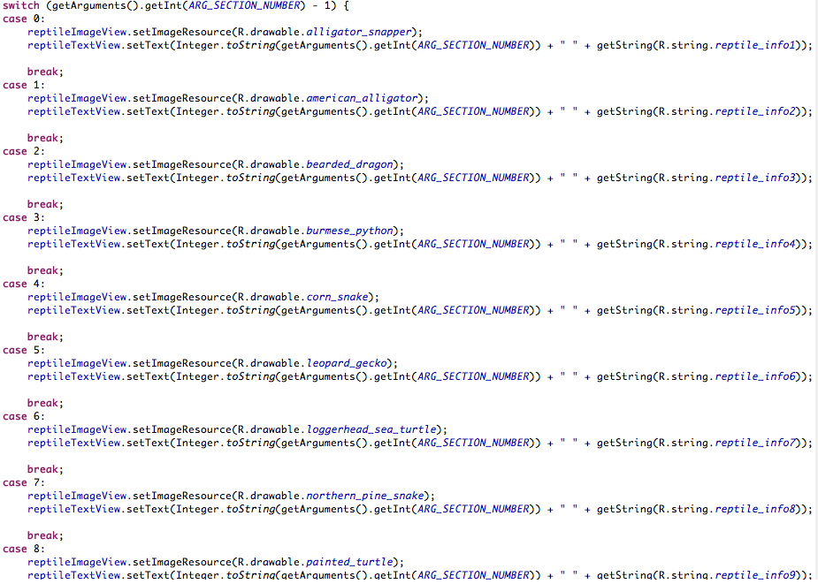

*The code shown above in the getPageTitle method is used to display the reptile’s name on the toolbar.* 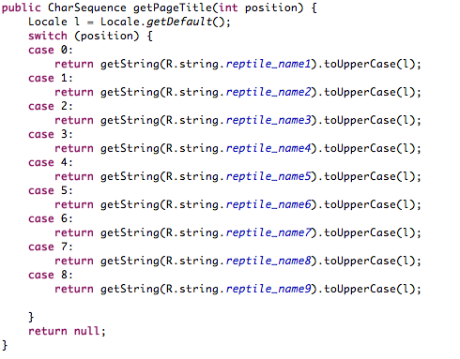

**RESULTS**

Our programmer was able to successfully implement all the necessary code that enables the user to navigate easily through the application. The ImageView and TextView are displayed below.

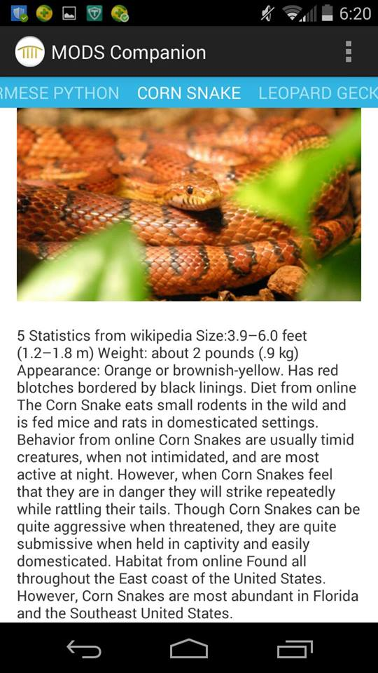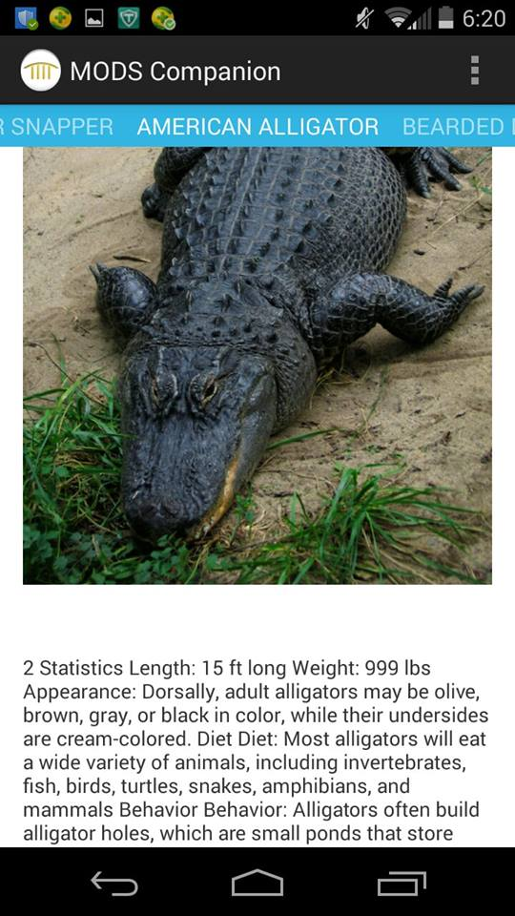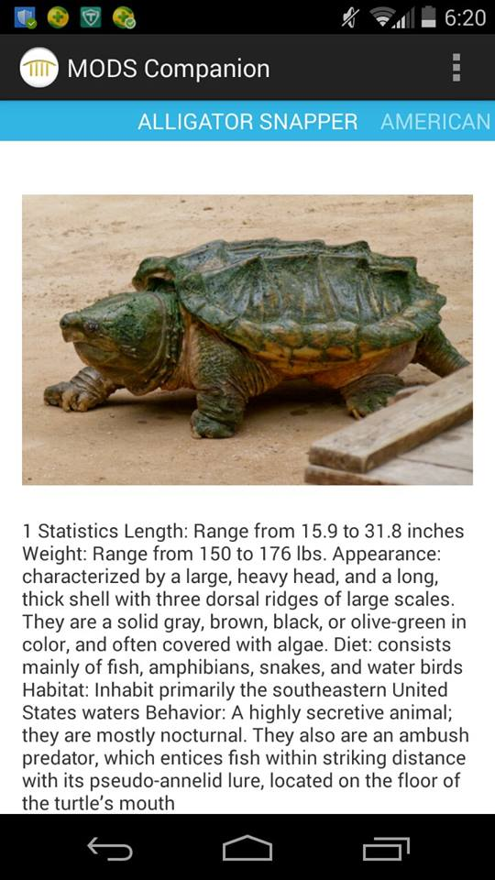

*Three different pages of the application are displayed.*

The information portion of the application can be opened by clicking on the second green lizard tab on the menu screen, which is labeled to the right of the lizard. This portion of our app includes various information such as size, weight, appearance, habitats, behavior, etc. We composed the information portion of our application with facts we collected from online sources, as well as information within the exhibits. It was our aim to enable the visitor to view the breadth of information within the convenient confines of their phone. Since it was our understanding that many parents find it hard to easily teach the information within the exhibit to their children,we ensured that the information we included is very easy to understand and comprehend, enabling the user to either learn or teach the information.

As a map was highly suggested by the museum representatives, we also successfully included a floor map of the facility.This feature provides a convenient guide of the vast museum, enabling any visitor roam freely while knowing where the nearest restroom, rest stop, or exhibit is.

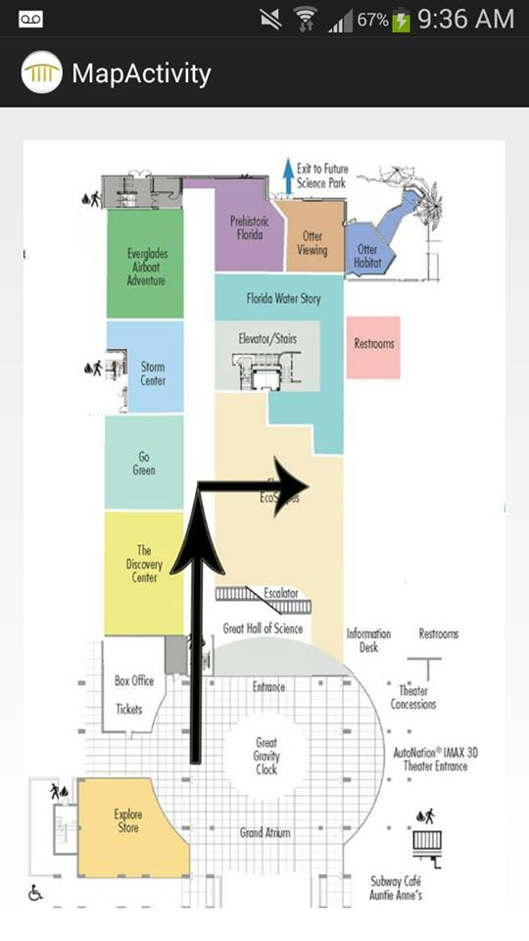

*The floor map with arrows pointing directly to the reptiles exhibit, as well as labeled exhibits and sections of the museum. Restroom symbols to indicate their location.*

**DISCUSSION**

The SectionPager Adapter was used to allow the user to swipe between reptiles easily and also provide a more advanced UI. Using a ScrollView, we were able to put more information on the screen and allow the user to scroll down. This gave us more space on the screen for more information and larger photos. The getPageTitle method controls the toolbar, which shows the name of the reptile. The SectionPager Adapter class contains the method onCreateView, which contains the switch and case statements that display the reptile pictures and information. We decided to use the SectionPager Adapter with the toolbar because we felt that the simple UI would be more beneficial to the user because this UI would be more simple for children, as well as parents and grandparents. We also felt that this UI was more clean and streamlined.

The UI we selected created a disadvantage, because the UI we selected was less colorful in the information section. We feel that although the information section was less colorful, the main screen compensated with its textured background and ImageView buttons. We chose to use ImageView buttons with the image of a lizard because our app focused on the reptiles, and lizards seemed like a good representation of the reptiles. The main screen has a UI that is based on the appearance of the lizard. The background contains a green, scaly background that represents the lizard’s skin, and the buttons were images of cartoon lizards.

Although the application has been completed for the reptiles, the app still needs to implement the rest of the exhibits, with different themed UI’s as appropriate. The app still needs information sections on the other exhibits, and could also benefit from an interactive map. The application could also benefit from a landscape optional UI. The current UI only supports portrait, but the landscape mode could provide a more detailed UI and can show more on the screen for the user.

**CONCLUSION**

We had run into some difficulties during the development of “The MODS Companion”. However, despite the difficulties, we completed our application to its fullest. The user is able to successfully able to navigate through the entire app with no bugs or setbacks, as well as navigate through the museum while knowing where the nearest exhibits and rest-rooms are via our map feature. Additionally, the main feature of our app, the Information portion, has been successfully implemented into our app with informative information and engaging graphics. With our original intents being to create an educational application for both adults and children, and to create an innovative tool for parents teaching their children as they make their way through the exhibit, we feel we have successfully completed our goal.

**REFERENCES**

"Alligator Snapping Turtle." *Alligator Snapping Turtle*. N.p., n.d. Web. 29 June 2014.

"Bearded Dragon - Woodland Park Zoo Seattle WA." *Bearded Dragon - Woodland Park Zoo Seattle WA*. N.p., n.d. Web. 29 June 2014.

"Burmese Pythons, Burmese Python Pictures, Burmese Python Facts - National Geographic." *National Geographic*. N.p., n.d. Web. 26 June 2014.

"Chattanooga Arboretum and Nature Center Northern Pine Snake, Habitat, Diet, Appearance, Interesting Facts." *Site*. N.p., n.d. Web. 29 June 2014.

"Corn Snake." *Fact Sheet*. N.p., n.d. Web. 29 June 2014.

"Leopard Gecko Care." *LEOPARDGECKO.COM*. N.p., n.d. Web. 29 June 2014.

Sauter, Daniel. *Rapid Android Development: Build Rich, Sensor-based Applications with Processing*. Dallas, Tx.: Pragmatic helf, 2013. Print.

**Appendix A- MODSCompanion Eclipse Project**

**Appendix B- Assets**

Appendices are attached as a Zip File.